CI/CD [Stands for Continuos Integration/Continuous Delivery] --- From Apna College(18 mins)

Software Development Lifecycle

Develop Stage
First we develop our feature, then we are going to commit and push the changes into our own branch.
So, in an organization there is a main branch and all the developers make changes and commit into their own branches, and after one point they integrate there own branch changes with the main branch.
After commiting anf pushing there is a build stage
Build Stage
Build stage is basically building deployable artifacts from the application code.
So, with the help of application source code and its dependencies and libraries we create a deployable artifact which are called build files. Inside build files there are binary files, executable files.
Test Stage
Like Unit Test Cases, which was generally done by developers, after unit testing we do integration testing (to check that after integration our different components are working correctly or not), then regression testing (to check that along with new changes our existing functionalities are working or not)
Release Stage
Making the entire application available to the end users to actually use it.
Inside releasing stage, there is deployment stage.
Deployment means, to make the application/code available at a particular environment. Different deployment environments is like dev (for developers), staging (pre-production env like for demo purpose), and prod environment (for end users).

This entire process is how we make any changes to the existing codebase/application.
Earlier, this whole process is done manually which tends to errors, and entire process is very time consuming. This is not a good way.
When we optimize/automate all these stages with the help of Scripts (like YAML scripts), and this automation process is called as CI/CD.
CI/CD consists of 2 steps-
Continuous Integration- Inside which our development lifecycle’s build and test stages are there. When we automate build and test stages, then this process is called as Continuous Integration.
And when we automate deployment/release stage, then we called it as Continuous Delivery.
Delivery means we’re delivering applications to the users.
In Continuous Delivery, suppose in staging env we have deployed the application, so generally before deploying to the production, in the continuous delivery there is a manual step, so at staging env someone needs to approve the changes then only the automatic deployment goes to prod env.
But in some organizations, after automatic deployment on staging, so without any manual approval the automatic deployment goes to production as well, and this is Continuous Deployment not Continuous Delivery.
After Continuous Integration ends, after that Continuous Delivery starts.

Why exactly do we need this automation?
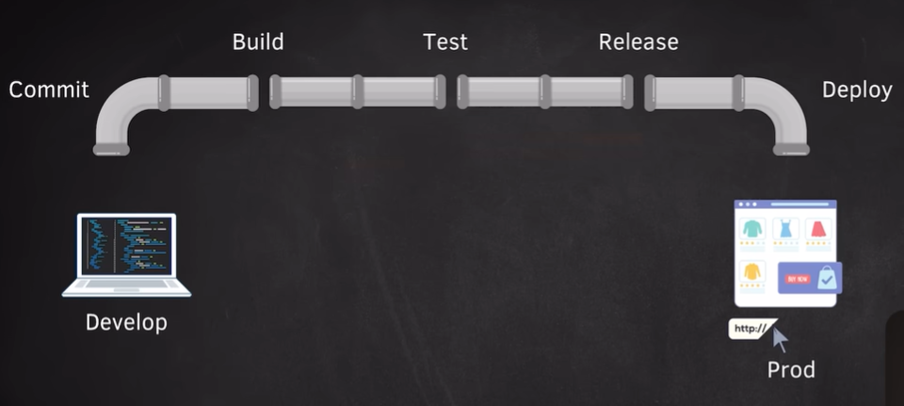
After the whole process, suppose the whole e-commerce application is available on prod. Suppose if we do all these things manually, then what problems will we face:
- Each developer does their changes on their own branch, after doing all the changes we required to integrate these changes, so when we merge different developers code, so there can be conflicts and other issues, and when we resolve these issues manually, then it’ll give arise to a problem called Integration Hell, which will take a lot of time and so many errors are left behind.
- Suppose we’ve done manual integration, but still we need to freeze our code b/s we need to test this application manually before integrating any new changes.
- Manual testing has problems of error prone and time consuming
- Another problem is infrequent release, b/s there is a code freeze, so manual testing and manual deployment takes time, so we can’t give new releases to the users frequently.
- If release and deployment stages are also manual, so there will be a common problem that is at the time of deployment on prod, if there is any error and if we want to go back to the previous version, so for that the process to backup and restore is also manual. Then users will encounter so many bugs or our application will be down, no one will be able to use that.
CI/CD makes this process simpler, and it has speed and reliability. Now the build and test are automated, so when any developer push the code to there local branch, so at that moment only we can check that if there is any problem in build stage and we can check that all the test cases are passed/not, this process is done generally on each and every commit. At this point of continuous integration, at any step if the test cases fail, then that particular developer can check and fix the problems in the code, and then they can re-commit the changes and integrate it with the main branch.
How do we implement CI/CD pipeline?
For that, we have to write automation scripts like github actions, in this we have to write YAML files (yet another markup language). In the YAML file we’ve to write some instructions like this:
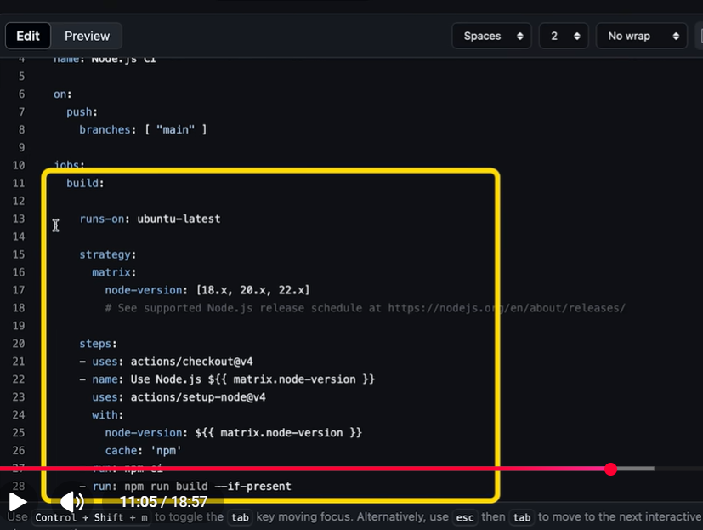
This is an example of script, which builds NodeJS code and then test. So whenever we push any new changes to our branch, so this will start a workflow.
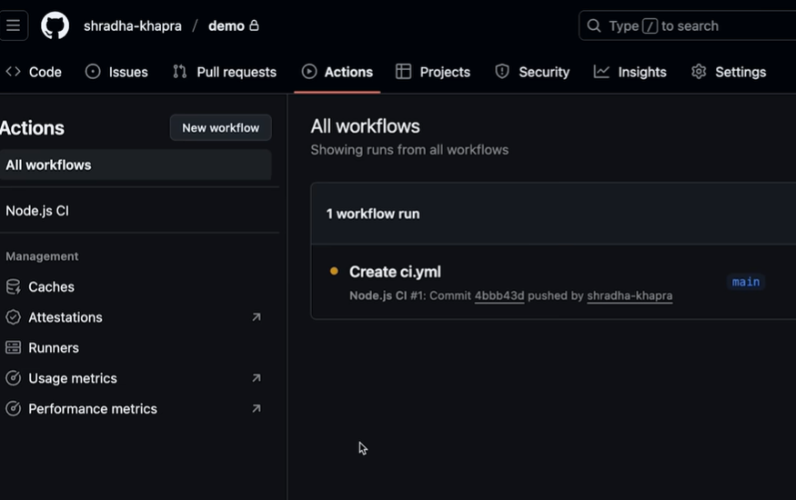
Inside workflow, the commands/instructions that we have written inside the script, will run one by one. And inside github, we can check each steps.
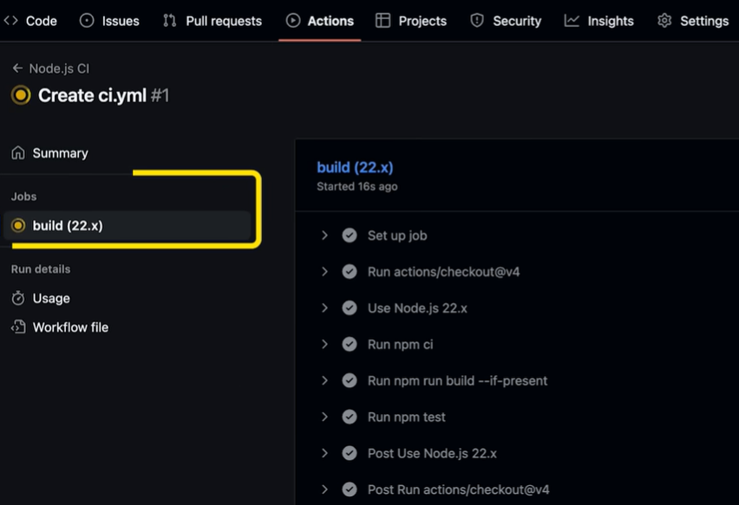

And if all the tests successfully passed, like in this example 2 test cases are passed, this means that the automation was successful, but if any of the test gets failed, so we can check at that particular step about what is the issue, and we can check which test cases are failed, and we can make the appropriate changes in the code.
CI/CD Tools
Github actions, Jenkins, Circle CI, Travis CI, Gitlab CI CD, Bamboo etc.
Delivery vs Deployment
After building and testing the code, now our code is ready to be deployed, building and testing comes under continuous integration, after that majorly we deploy our application into staging env, after that we perform end-to-end testing (like compliance, performance and security tests), after successful testing, generally we’ll get a manual approval from a manager, after which we deploy on prod, so this whole process is c/d as continuous delivery, b/s in this manual approval is involved.
But in the same process, if we remove the manual approval, and the entire flow works in an automated manner, like after the test is successful, we don’t need any manual approval to deploy it to prod env, then this type of deployment is c/d as continuous deployment
Generally, majority organizations follows continuous delivery.
If we have very sensitive data, like banking application where we’ve financial records of the people. So, whenever any new changes is done, so we need manual approval for that. So continuous delivery is better suited for that

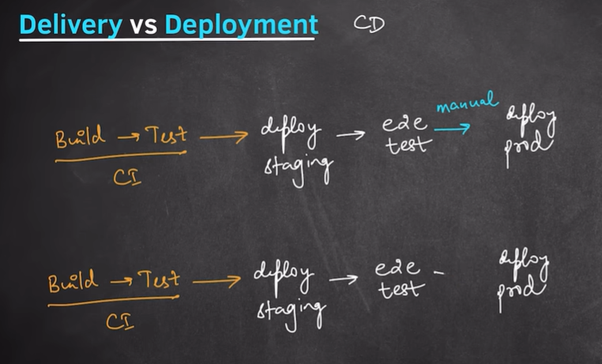
And if we are building applications like Netflix, Hotstar in which majority of the changes are not that sensitive, and we’ve a well established devops team, so in that case we follow continuous deployment
After building, testing, and deploying application, but still there is any bug that goes till prod level, so for that we use different deployment strategies, so that we have almost zero downtime
Deployment strategies:
- Blue Green Deployment- In this for our application, we create 2 identical but separate environments. Blue env holds current version of the application and Green env holds new version of the application. Suppose v3 is the current version and we want to move to v4 version, so we keep both these versions in a separate env.
So, all the traffic which was coming at v3 version, so we will redirect all the traffic to v4 version, now all the users are at version v4, if something goes wrong at version v4 so we can redirect the whole traffic back to the previous version v3
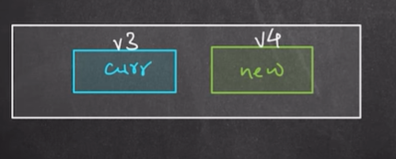
- Canary Deployment- In this, we will not redirect the whole traffic to the new version, initially we redirect very less traffic to new version.
Suppose if we’ve 100 users, from that 100 users, we will give only 5 to 10% of users to use the application for 2 to 3 hours and will redirect to the new version, and if everything is working fine, so we increase the % of users redirection, and progressively we increase the no. of users to go to the new version, and then there is a point where all the users are using our new application. In case, if there is any problem in the new app, so we can redirect them to the old version.

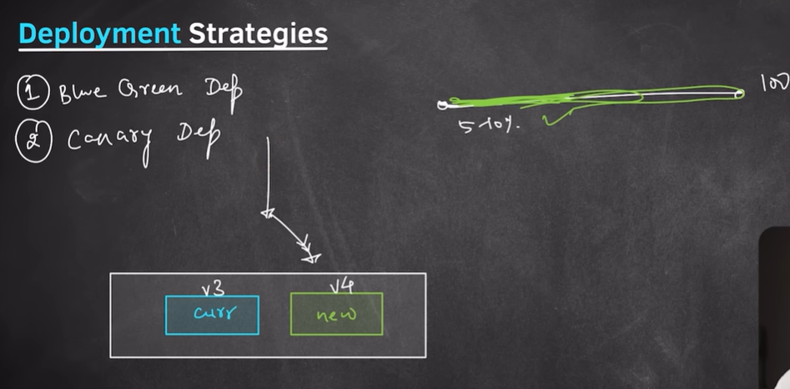

- Rolling Deployment- We have a load balancer, which is connected to different instances, i.e. request goes to multiple instances, to some of the instances we deploy the new version and to other instances old version is deployed, so we can test particular users on a particular instance to know that everything is working fine on the new version, and if everything goes well then we deploy new version to other instances as well

